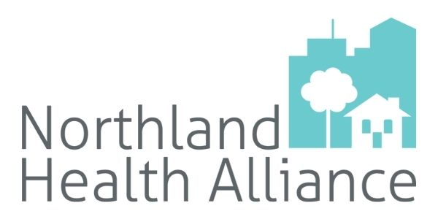
Copy Examples for Promoting the 2025 Northland Community Health Assessment
Download high-resolution graphics and flyers at https://northlandkchealthalliance.org/promotional-materials/

Newsletter 1 (Thanks):
Last year, as a member of the Northland Health Alliance (NHA), we asked for your feedback on how easy or difficult it is to be healthy in the Northland. Over 100 people attended community forums and 1,876 filled out our survey – thank you!
By combining your valuable feedback with local health data, NHA created an updated Community Health Assessment (CHA). The updated CHA can be viewed here. There is a wealth of information on this interactive dashboard, from downloadable graphs to interesting insights.
From 2026-2028, NHA’s task forces will work to improve access to healthy food, healthcare and mental/behavioral health in the area.

Newsletter 2 (Data Points & Moving Forward):
Knowledge is power. To better serve our community, the Northland Health Alliance gathered data and feedback from community members over the last year. A few things we learned:
- 2 in 5 Northland residents live in areas without easy access (<1 mile urban, <10 miles rural) to grocery stores selling fresh & healthy food.
- There is 1 mental health provider per 632 people in Platte County (1 per 500 is the generally acceptable ratio). Clay Country has 1 per 573 people.
- 30.4% of Northland adults have high blood pressure.
- 1 in 5 Northland adults have not visited the dentist in the past 2 years.
Based on this information, NHA plans to tackle these priority areas in 2026-2028: access to health care, access to healthy food, and mental/behavioral health. Dedicated task forces will unite healthcare providers and organizations in the area to make a difference in the health of the community. We’re excited to get to work!
Check out the NEW Community Health Assessment: northlandkchealthalliance.org/cha
Newsletter 3 (Dashboard focused):
We’re excited to announce the newest version of Northland Health Alliance’s community health dashboard is now available! This online resource can be an incredibly valuable tool for local leaders, difference makers, and anyone wanting to better understand health in Clay and Platte counties.
You can find Northland-focused data in these categories:
- Chronic disease (asthma, diabetes, sleep, nutrition, cancer, physical activity)
- Maternal and infant health (infant mortality rate, prenatal care, tobacco use)
- Economics (household incomes, WIC and SNAP participation, unemployment, poverty)
- Access to health care (frequency of health visits, health care provider ratios, uninsured)
- Built environment (walkability, commutes, air quality, crime, internet access)
- Preventable conditions (vaccination, STIs, screenings, hospitalizations)
- Mental/behavioral health (depression, suicide, overdoses, alcohol, youth substance use)
- Mortality (what’s causing deaths in the Northland)
Over 80 graphs and data points are available to customize and download.
Want to help us get the word out about this resource? Find a promotional toolkit here.
[OR]
Want a guided tour through the dashboard? Join its creators on Thursday, Sept. 11 at 11 a.m. for a virtual tour. Register to get the link to join at https://forms.gle/ANNK6isvx3nhStuP8.

Social Media
General graphics 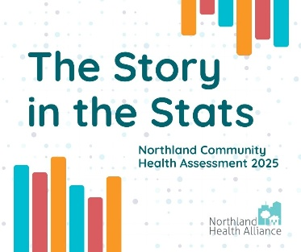  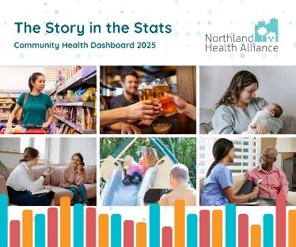  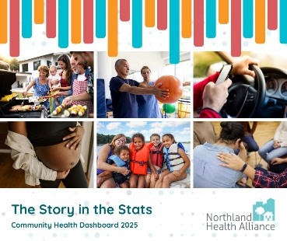 | We’re excited to announce the newest version of Northland Health Alliance’s community health dashboard is now available! 🎉This online resource can be an incredibly valuable tool for local leaders, difference makers, and anyone wanting to better understand health in Clay and Platte counties. Over 80 graphs and data points are available to view, interact with, and download.  Check it out ➡️ northlandkchealthalliance.org/cha  The information collected helps NHA know what the Northland needs most to be healthier. From 2026-2028, NHA’s task forces will focus on improving access to healthcare, access to healthy food, and access to mental/behavioral health resources.
Webinar Invite  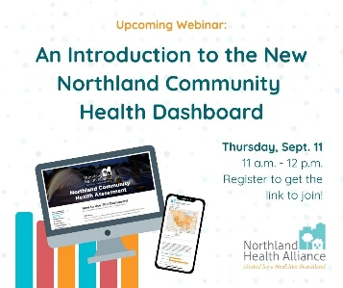 | Join the creators of the new Northland community health dashboard on Thursday, Sept. 11 at 11 a.m. for a detailed walkthrough of this valuable resource. This session will be helpful for local leaders who use data to serve their communities, but all are welcome!  Register now to get the link to join: https://forms.gle/ANNK6isvx3nhStuP8
Interactive CHA  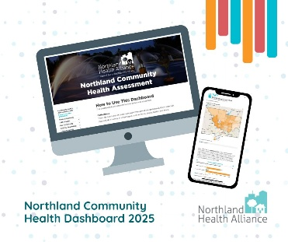 | Long, boring PDF no more! Northland Health Alliance’s latest Community Health Assessment (CHA) is now available as an online, interactive dashboard.  Go to northlandkchealthalliance.org/cha to find local health data + learn how/why NHA decided to focus on improving access to health food, healthcare, and mental health for the next 3 years.
Improved Navigation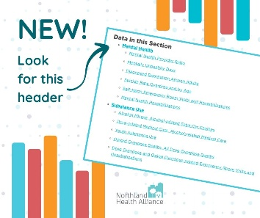 | It's easier than ever to find the health data you’re looking for! In the Northland Health Alliance’s latest community health dashboard, you can now navigate straight to the topic you’re interested in through the Table of Contents tab or sections labeled Data in this Section.  Whether you’re looking for stats regarding chronic disease, transportation, overdoses, or maternal health, these links will help you out. https://dashboards.mysidewalk.com/northland-health-alliance-area-community-health-assessment-1edecc1de771/table-of-contents
CHA Creation Timeline  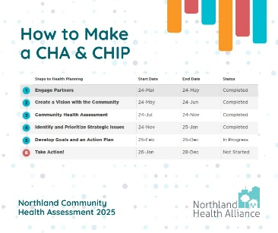 | A community health assessment (CHA), updated every 3-5 years, is necessary for healthcare organizations to understand the greatest needs in their areas. By knowing the greatest needs, they can create a CHIP, or community health improvement plan, and work together to tackle the biggest barriers to living healthy lives.  The Northland Health Alliance started work on the latest CHA & CHIP in March of 2024. Since then, NHA and its members like us connected with partners and community members, identified issues, and set goals. Now, we’re ready to take action!  Read more about what we learned and what’s next in the CHA dashboard: northlandkchealthalliance.org/cha
Thanks for Your Feedback  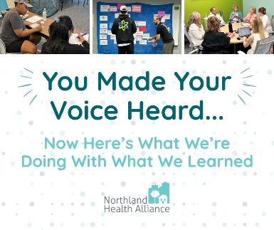  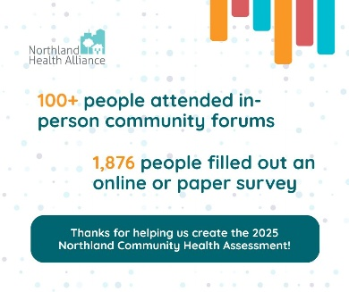 | Thank you! 👏 If you filled out the Northland Health Alliance survey or participated in a community forum in 2024, you helped guide your local health organizations’ goals for the next few years.  By sharing your perspective, local hospitals, health departments, mental health providers, non-profits got to hear what real people in the Northland are struggling with when it comes to being healthy.  Community feedback + data combined to form a community health assessment (northlandkchealthalliance.org/cha). This assessment helped create a plan. From 2026-2028, the Northland Health Alliance will work to improve access to healthy food, healthcare and mental/behavioral health in the area.
Data Highlight  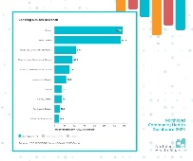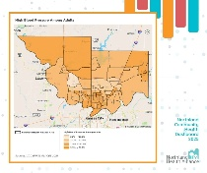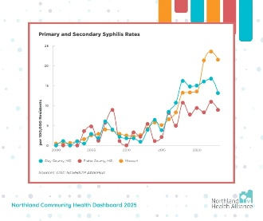 | [Use this Canva template to highlight a certain data point. Download and customize graphs from the CHA dashboard - northlandkchealthalliance.org/cha)

